PROJECT DEVELOPMENT PHASE

SPRINT-4

PNT2022TMID42730

**PROJECT NAME : INDUSTRY SPECIFIC INTELLIGENT FIRE MANGEMENT SYSTEM**

**:** PNT2022TMID05194

**TEAM ID**

#include <WiFi.h> #include <PubSubClient.h> #define temp_pin 15

void callback(char* subscribetopic,byte* payload, unsigned int payloadLength); #define ORG "jesccj"

#define DEVICE_TYPE "ESP32_Controller" #define DEVICE_ID "PURNI"

#define TOKEN "*Vzh&EwwgbRpqohJd+" String data3;

char server[]= ORG ".messaging.internetofthings.ibmcloud.com"; char publishTopic[]="iot-2/evt/Data/fmt/json";

char subscribeTopic[]="iot-2/cmd/test/fmt/String"; char authMethod[]="use-token-auth";

char token[]=TOKEN;

char clientID[]="d:"ORG":"DEVICE_TYPE":"DEVICE_ID;

WiFiClient wifiClient;

PubSubClient client(server,1883,callback,wifiClient);

// should match the Beta Coefficient of the thermistor void setup() {

**Serial**.begin(9600); analogReadResolution(10); pinMode(32,INPUT); pinMode(14,OUTPUT);

wificonnect(); mqttconnect();

}

void loop() {

const float BETA = 3950; // should match the Beta Coefficient of the thermistor int analogValue = analogRead(A4);

float temp = 1 / (log(1 / (1023. / analogValue - 1)) / BETA + 1.0 / 298.15) - 273.15;

//float temp = 1 / (log(1 / (1023. / analogValue - 1)) / BETA + 1.0 / 298.15) - 273.15;

**Serial**.print("Temperature: "); **Serial**.print(temp); **Serial**.println(" ℃"); if(temp>=35){

PublishData2(temp); digitalWrite(14, HIGH);

}else{

digitalWrite(14, LOW); PublishData1(temp);

}

delay(1000); if(!client.loop()){

mqttconnect();

}

//delay(2000);

}

void PublishData1(float tem){ mqttconnect();

String payload= "{\"temp\":"; payload += tem;

payload+="}";

**Serial**.print("Sending payload:");

**Serial**.println(payload);

if(client.publish(publishTopic,(char*)payload.c_str())){

**Serial**.println("publish ok");

} else{

**Serial**.println("publish failed");

}

}

void PublishData2(float tem){ mqttconnect();

String payload= "{\"ALERT\":"; payload += tem;

payload+="}";

**Serial**.print("Sending payload:");

**Serial**.println(payload);

if(client.publish(publishTopic,(char*)payload.c_str())){

**Serial**.println("publish ok");

} else{

**Serial**.println("publish failed");

}

}

void mqttconnect(){ if(!client.connected()){

**Serial**.print("Reconnecting to"); **Serial**.println(server); while(!!!client.connect(clientID, authMethod, token)){

**Serial**.print("."); delay(500);

}

initManagedDevice();

**Serial**.println();

}

}

void wificonnect(){ **Serial**.println(); **Serial**.print("Connecting to");

WiFi.begin("Wokwi-GUEST","",6); while(WiFi.status()!=WL_CONNECTED){

delay(500);

**Serial**.print(".");

}

**Serial**.println(""); **Serial**.println("WIFI CONNECTED"); **Serial**.println("IP address:"); **Serial**.println(WiFi.localIP());

}

void initManagedDevice(){ if(client.subscribe(subscribeTopic)){

**Serial**.println((subscribeTopic)); **Serial**.println("subscribe to cmd ok");

}else{

**Serial**.println("subscribe to cmd failed");

}

}

void callback(char* subscribeTopic, byte* payload, unsigned int payloadLength){

**Serial**.print("callback invoked for topic:");

**Serial**.println(subscribeTopic); for(int i=0; i<payloadLength; i++){

data3 += (char)payload[i];

}

**Serial**.println("data:"+ data3); if(data3=="lighton"){

**Serial**.println(data3); digitalWrite(14,HIGH);

}else{

**Serial**.println(data3); digitalWrite(14,LOW);

}

data3="";

}

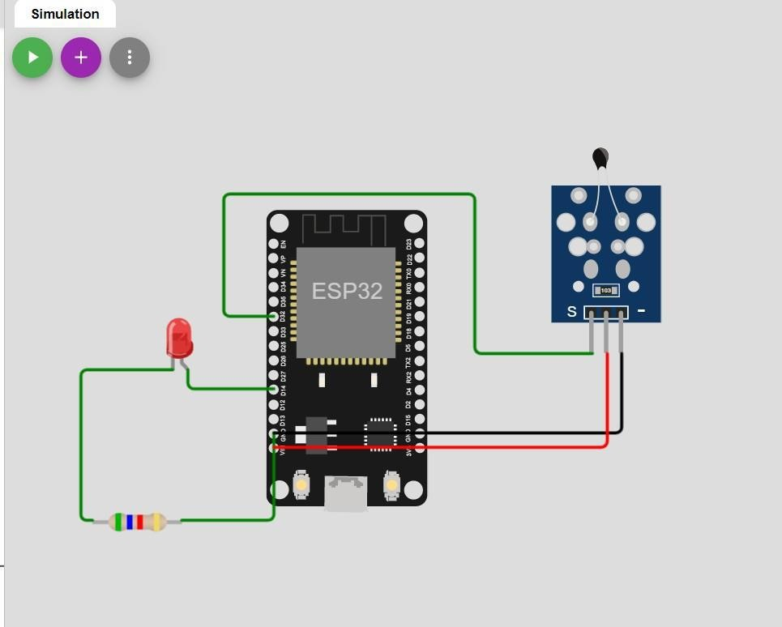DIAGRAM:

